The National Network of Library of Medicine requires that we complete evaluations for our WebLitLegit Workshop. Trainers will complete 2 evaluations. Teens will complete one evaluation. All evaluations should only take a few minutes.

WebLitLegit Trainer Workshop Evaluation

Please complete the evaluation for each workshop that you provide.
This is mandatory and only takes a few minutes to complete.

Click QR Code to access the

Workshop evaluation on your phone.
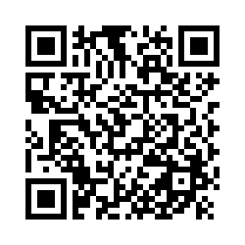
WebLitLegit Trainer Workshop Evaluation

WebLitLegit Show Me Demonstration

Please evaluate a few teens individually on their ability to locate and evaluate websites. This is good data to capture, please try to complete for at least a few teens at each session. Only takes a minute to complete.

Click QR Code to access the

Show Me Demonstration on your phone.

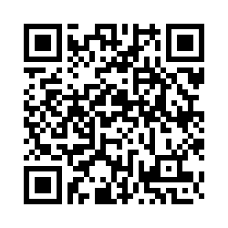
WebLitLegit Show Me Demonstration

WebLitLegit Trainer Workshop Evaluation

- Date of WebLitLegit Workshop
________________________________________________________________

- Location of WebLitLegit Workshop
________________________________________________________________

- Were teen participants able to find session room easily?
- Yes
- No, please explain ________________________________________________

- Was there ample parking?
- Yes
- No, please explain ________________________________________________

- Could teens access information on smartphones?
- Yes
- No, please explain ________________________________________________

- Did venue have Wifi access during the session?
- Yes
- No, please explain ________________________________________________

- What teen health resources did you use to teach or demonstrate during the WebLitLegit workshop? Check all that apply.
- Medline Plus
- KidsHealth
- CDC
- Other, please list ________________________________________________

- Was teen able to locate a health information site?
- Yes
- No, please explain ________________________________________________

- How important was the WebLitLegit workshop fee ($250) to make it feasible for your organization to offer workshops to teens?
- Not important
- A little important
- Important
- Very important

“This project was supported by the National Network of the Libraries of Medicine under Award Number 1UG4LM012345-01. The content is solely the responsibility of the authors and does not necessarily represent the official views of the National Institutes of Medicine.”

Teen Show Me Demonstration----WebLitLegit

Observe and/or ask the teen to talk out how they are thinking as they look up a health website. Check off how the teen was able to appraise a health website--- independently, with coaching from you or not at all.

 | Independently | With coaching | Not at all
Identifies who runs or created the site.
Indicates reasons can trust or not trust the site.
Indicates date when information was written/revised.
Indicates where information comes from- is it based in science?
Indicates why site exists and whether it is selling something.

This project was supported by the National Network of the Libraries of Medicine under Award Number 1UG4LM012345-01. The content is solely the responsibility of the authors and does not necessarily represent the official views of the National Institutes of Medicine.”

Teen WebLitLegit Workshop Evaluation

Please complete this evaluation at the end of the workshop

Click on the QR code to access evaluation on your phone
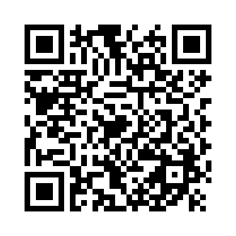

TeenWebLitLegit Workshop Evaluation

Teen WebLitLegit Evaluation Survey

- What grade are you in?
- 5th grade
- 6th grade
- 7th grade
- 8th grade
- 9th grade
- 10th grade
- 11th grade
- 12th grade
- Other ________________________________________________

- How old are you?
________________________________________________________________

- How confident do you feel using Medline Plus?
- Not confident
- A little confident
- Pretty confident
- Completely confident

- How confident do you feel about locating health information on the internet?
- Not confident
- A little confident
- Pretty confident
- Completely confident

- How confident do you feel about telling reliable from unreliable health information on the internet?
- Not confident
- A little confident
- Pretty confident
- Completely confident

- How confident do you feel about making health decisions using health information on the internet?
- Not confident
- A little confident
- Pretty confident
- Completely confident

- How likely are you to recommend the WebLitLegit workshop to your friends?
- Unlikely
- Somewhat unlikely
- Somewhat likely
- Likely

- How was the time for the WebLitLegit?
- Too short
- Right amount of time
- Too long

- Did the WebLitLegit workshop introduce you to at least one health information resource or tool that you had never used before?
- Yes
- No
- Not applicable

- Did you learn a new skill in this WebLitLegit workshop that you plan to use in the future?
- Yes
- No
- Not applicable

- Did you improve your ability to apply a resource you already use?
- Yes
- No
- Not applicable

- Please indicate your level of agreement with each statement
 | Strongly Agree | Somewhat Agree | Somewhat Disagree | Strongly Disagree | Not Applicable
This WebLitLegit workshop improve my ability to find useful online health information
I plan to start using at least one resource or tool that I learned about in the WebLitLegit workshop
I plan to tell others about at least one resource or tool that I learned about in the WebLitLegit workshop

This project was supported by the National Network of the Libraries of Medicine under Award Number 1UG4LM012345-01. The content is solely the responsibility of the authors and does not necessarily represent the official views of the National Institutes of Medicine.”

