The National Network of Library of Medicine requires that we complete evaluations for our WebLitLegit Workshop. Trainers will complete 2 evaluations. Teens will complete one evaluation. All evaluations should only take a few minutes.
- WebLitLegit Trainer Workshop Evaluation
Please complete the evaluation for each workshop that you provide.
This is mandatory and only takes a few minutes to complete.

Click QR Code to access the
Workshop evaluation on your phone.
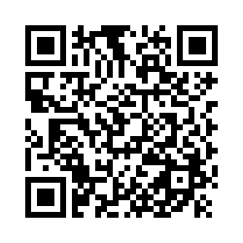
- WebLitLegit Show Me Demonstration
Please evaluate a few teens individually on their ability to locate and evaluate websites. This is good data to capture, please try to complete for at least a few teens at each session. Only takes a minute to complete.

Click QR Code to access the
Show Me Demonstration on your phone.

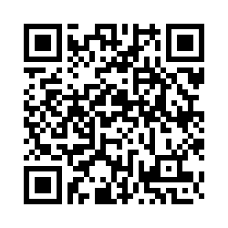
WebLitLegit Trainer Workshop Evaluation

Q1 Date of WebLitLegit Workshop
________________________________________________________________

Q2 Location of WebLitLegit Workshop
________________________________________________________________

Q3 Were teen participants able to find session room easily?
- Yes
- No, please explain ________________________________________________

Q4 Was there ample parking?
- Yes
- No, please explain ________________________________________________

Q5 Could teens access information on smartphones?
- Yes
- No, please explain ________________________________________________

Q6 Did venue have Wifi access during the session?
- Yes
- No, please explain ________________________________________________

Q7 What teen health resources did you use to teach or demonstrate during the WebLitLegit workshop? Check all that apply.
- Medline Plus
- KidsHealth
- CDC
- Other, please list ________________________________________________

Q8 Was teen able to locate a health information site?
- Yes
- No, please explain ________________________________________________

Q9 How important was the WebLitLegit workshop fee ($250) to make it feasible for your organization to offer workshops to teens?
- Not important
- A little important
- Important
- Very important

“This project was supported by the National Network of the Libraries of Medicine under Award Number 1UG4LM012345-01. The content is solely the responsibility of the authors and does not necessarily represent the official views of the National Institutes of Medicine.”

Teen Show Me Demonstration----WebLitLegit

Observe and/or ask the teen to talk out how they are thinking as they look up a health website. Check off how the teen was able to appraise a health website--- independently, with coaching from you or not at all.
 | Independently | With coaching | Not at all
Identifies who runs or created the site
Indicates reasons can trust or not trust the site
Indicates date when information was written/revised
Indicates where information comes from- is it based in science?
Indicates why site exists and whether it is selling something

This project was supported by the National Network of the Libraries of Medicine under Award Number 1UG4LM012345-01. The content is solely the responsibility of the authors and does not necessarily represent the official views of the National Institutes of Medicine.”

Teen WebLitLegit Workshop Evaluation

Please complete this evaluation at the end of the workshop

Click on the QR code to access evaluation on your phone

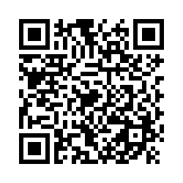

Teen WebLitLegit Evaluation Survey

Q1 What grade are you in?
- 5th grade
- 6th grade
- 7th grade
- 8th grade
- 9th grade
- 10th grade
- 11th grade
- 12th grade
- Other ________________________________________________

Q2 How old are you?
________________________________________________________________

Q3 How confident do you feel using Medline Plus?
- Not confident
- A little confident
- Pretty confident
- Completely confident

Q4 How confident do you feel about locating health information on the internet?
- Not confident
- A little confident
- Pretty confident
- Completely confident

Q5 How confident do you feel about telling reliable from unreliable health information on the internet?
- Not confident
- A little confident
- Pretty confident
- Completely confident

Q6 How confident do you feel about making health decisions using health information on the internet?
- Not confident
- A little confident
- Pretty confident
- Completely confident

Q7 How likely are you to recommend the WebLitLegit workshop to your friends?
- Unlikely
- Somewhat unlikely
- Somewhat likely
- Likely

Q8 How was the time for the WebLitLegit?
- Too short
- Right amount of time
- Too long

Q9 Did the WebLitLegit workshop introduce you to at least one health information resource or tool that you had never used before?
- Yes
- No
- Not applicable

Q10 Did you learn a new skill in this WebLitLegit workshop that you plan to use in the future?
- Yes
- No
- Not applicable

Q11 Did you improve your ability to apply a resource you already use?
- Yes
- No
- Not applicable

Q12 Please indicate your level of agreement with each statement

 | Strongly Agree | Somewhat Agree | Somewhat Disagree | Strongly Disagree | Not Applicable
This WebLitLegit workshop improve my ability to find useful online health information
I plan to start using at least one resource or tool that I learned about in the WebLitLegit workshop
I plan to tell others about at least one resource or tool that I learned about in the WebLitLegit workshop

This project was supported by the National Network of the Libraries of Medicine under Award Number 1UG4LM012345-01. The content is solely the responsibility of the authors and does not necessarily represent the official views of the National Institutes of Medicine.”

